Nama : Afad Fath Musyarof Halim  
NIM : 2211104030  
Kelas : 2211104030

# Tugas 8 - REST API

Note: Menggunakan [JSONPlaceholder - Free Fake REST API](https://jsonplaceholder.typicode.com/)

Kodingan

|  |
| --- |
| import 'package:flutter/material.dart';  import 'package:get/get.dart';  import '../screen/home_screen.dart';  void main() {  runApp(const MainApp());  }  class MainApp extends StatelessWidget {  const MainApp({super.key});  @override  Widget build(BuildContext context) {  return GetMaterialApp(  title: 'Catatan',  initialRoute: '/',  getPages: [  GetPage(name: '/', page: () => HomeScreen()),  ],  );  }  } |

1. Main.dart
2. Homescreen

|  |
| --- |
| import 'package:flutter/material.dart';  import 'package:get/get.dart';  import '../service/getx_controller.dart';  void main() => runApp(HomeScreen());  class HomeScreen extends StatelessWidget {  HomeScreen({super.key});  final ControllerX _controller = Get.put(ControllerX());  @override  Widget build(BuildContext context) {  return MaterialApp(  home: Scaffold(  appBar: AppBar(  title: const Text('JSONPlaceholder'),  ),  body: Padding(  padding: const EdgeInsets.all(8.0),  child: Column(  children: [  Row(  mainAxisAlignment: MainAxisAlignment.spaceEvenly,  children: [  ElevatedButton(  onPressed: _controller.fetchPosts,  child: const Text('Fetch Posts'),  ),  ElevatedButton(  onPressed: _controller.createPost,  child: const Text('Create Post'),  ),  ],  ),  Row(  mainAxisAlignment: MainAxisAlignment.spaceEvenly,  children: [  ElevatedButton(  onPressed: _controller.updatePost,  child: const Text('Update Post'),  ),  ElevatedButton(  onPressed: _controller.deletePost,  child: const Text('Delete Post'),  ),  ],  ),  const SizedBox(height: 10),  Obx(  () {  if (_controller.isLoading.value) {  return const CircularProgressIndicator();  } else {  return Expanded(  child: ListView.builder(  itemCount: _controller.posts.length,  itemBuilder: (context, index) {  final post = _controller.posts[index];  return ListTile(  title: Text(post['title']),  subtitle: Text(post['body']),  );  },  ),  );  }  },  ),  ],  ),  ),  ));  }  } |

1. API Service

|  |
| --- |
| import 'dart:convert';  import 'package:http/http.dart' as http;  class ApiService {  final String baseUrl = 'https://jsonplaceholder.typicode.com';  List<dynamic> posts = [];  Future<void> fetchPosts() async {  final response = await http.get(Uri.parse('$baseUrl/posts'));  if (response.statusCode == 200) {  posts = jsonDecode(response.body);  } else {  throw Exception('Failed to load posts');  }  }  // Fungsi untuk POST data  Future<void> createPost() async {  final response = await http.post(  Uri.parse('$baseUrl/posts'),  headers: {'Content-Type': 'application/json'},  body: json.encode({  'title': 'Flutter Post',  'body': 'Ini contoh POST.',  'userId': 1,  }),  );  if (response.statusCode == 201) {  posts.add({  'title': 'Flutter Post',  'body': 'Ini contoh POST.',  'id': posts.length + 1,  });  } else {  throw Exception('Failed to create post');  }  }  // Fungsi untuk UPDATE data  Future<void> updatePost() async {  final response = await http.put(  Uri.parse('$baseUrl/posts/1'),  body: json.encode({  'title': 'Updated Title',  'body': 'Updated Body',  'userId': 1,  }),  );  if (response.statusCode == 200) {  final updatedPost = posts.firstWhere((post) => post['id'] == 1);  updatedPost['title'] = 'Updated Title';  updatedPost['body'] = 'Updated Body';  } else {  throw Exception('Failed to update post');  }  }  // Fungsi untuk DELETE data  Future<void> deletePost() async {  final response = await http.delete(  Uri.parse('$baseUrl/posts/1'),  );  if (response.statusCode == 200) {  posts.removeWhere((post) => post['id'] == 1);  } else {  throw Exception('Failed to delete post');  }  }  } |

1. getx_controller

|  |
| --- |
| import 'package:get/get.dart';  import '../service/api_service.dart';  class ControllerX extends GetxController {  var posts = <dynamic>[].obs;  var isLoading = false.obs;  final ApiService _apiService = ApiService();  void showSnackBar(String title, String message) {  Get.snackbar(title, message, snackPosition: SnackPosition.TOP);  }  Future<void> handleApiOperation(  Future<void> operation, String title, String successMessage) async {  isLoading.value = true;  try {  await operation;  posts.value = _apiService.posts;  showSnackBar(title, successMessage);  } catch (e) {  showSnackBar("Error", e.toString());  } finally {  isLoading.value = false;  }  }  void fetchPosts() =>  handleApiOperation(_apiService.fetchPosts(), "Fetch", 'Fetch Posts');  void createPost() =>  handleApiOperation(_apiService.createPost(), "Create", 'Create Post');  void updatePost() =>  handleApiOperation(_apiService.updatePost(), "Update", 'Update Post');  void deletePost() =>  handleApiOperation(_apiService.deletePost(), "Delete", 'Delete Post');  } |

Hasil

1. Home – Get  
   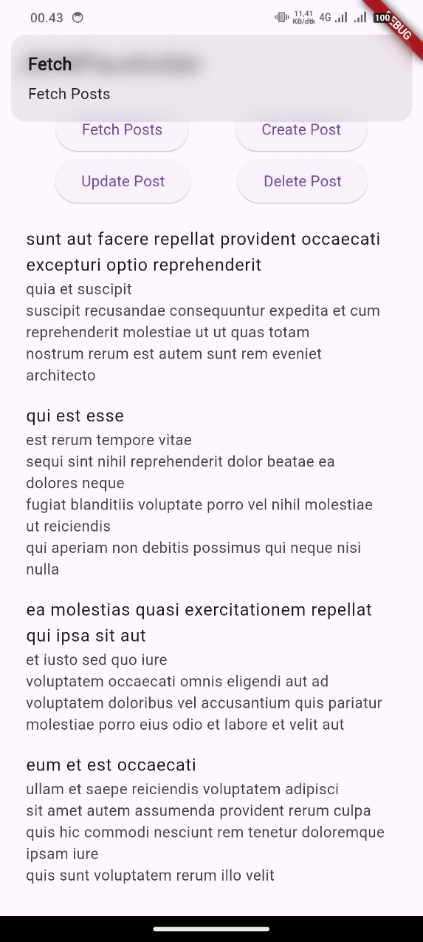
2. Home – Create  
   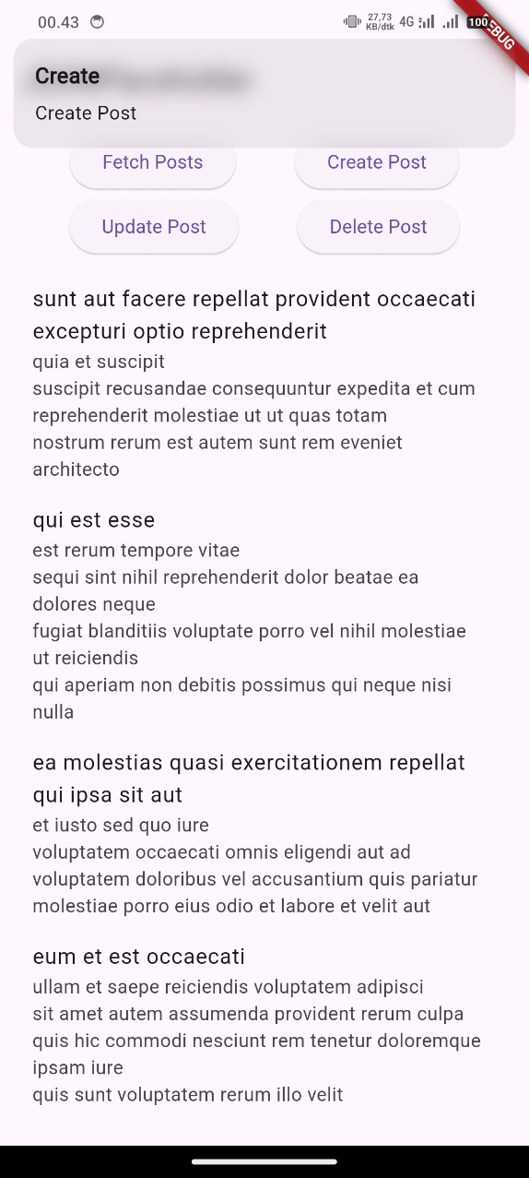
3. Home – Delete  
   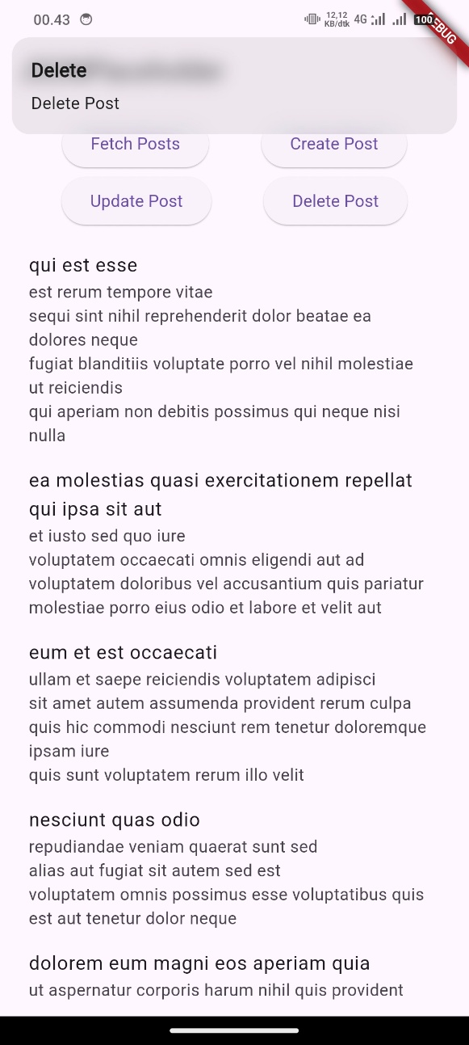
4. Home – Update  
   